Name(s) ______________________

GeoMapApp lab
Download Application from: http://www.geomapapp.org/

PART 1: PROJECTIONS
- Open GeoMapApp and select the first map projection. Write down which projection you will be using.

- Based on the lecture which area on the globes does this projection most accurately portray?

- Which projection should you use if you are studying the North Pole?

- Which projection should you use if you are studying a map of the entire USA?

- Draw the tool to use for zooming

Zoom in: Zoom out:

- What happens to the RESOLUTION of the data as you zoom in?

- Label in order of resolution (1= lowest resolution 4=highest resolution)
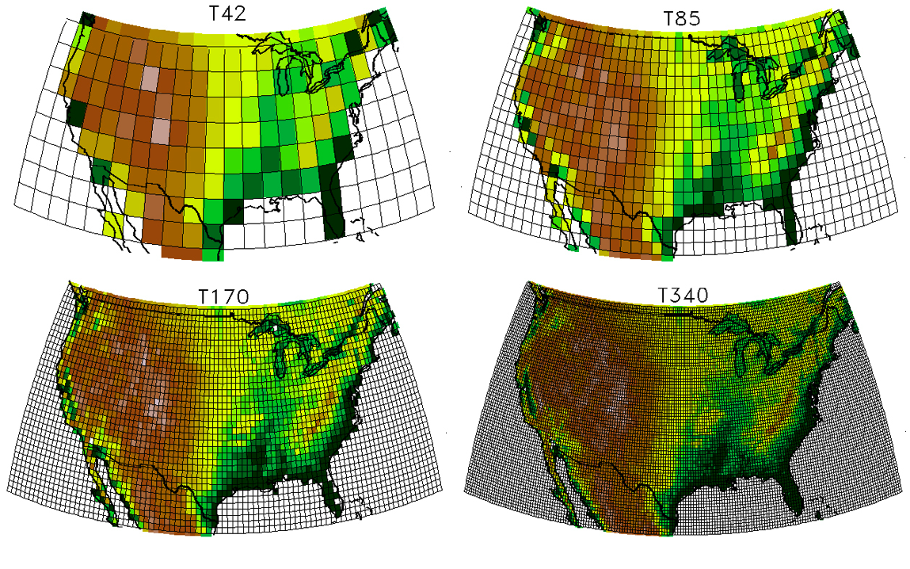

PART 2: GEOMAPAPP
- Zoom out to find South America. Now zoom in to the NW quadrant of this continent as seen below, then using the profile tool, draw a line from offshore to onshore and sketch on the back page of your lab what your profile looks like and label the major features you see.
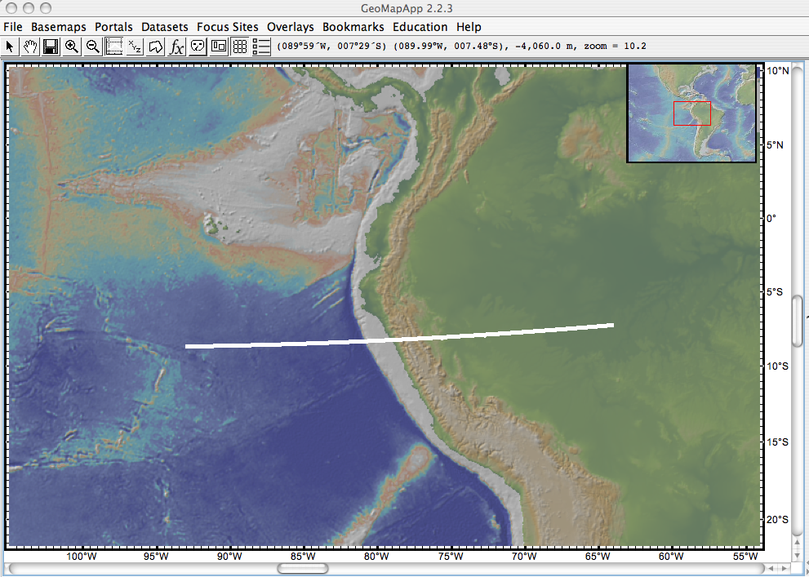

- What type of plate boundary is this (convergent, divergent or transform)? circle one.
- Now, go to the menu bar and click “Focus Sites > NSF Margins > Central America > Seafloor Photos > Costa Rica Trench Dive Photos.
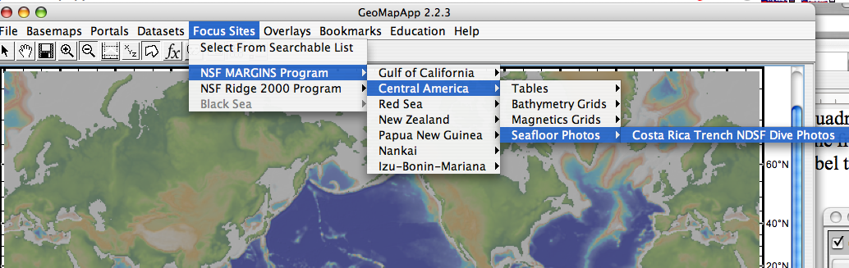

A window called ‘Shapefile Manager’ should pop up. First click the zoom buttom so that the main window shows you the data. Then, click on the information tab. 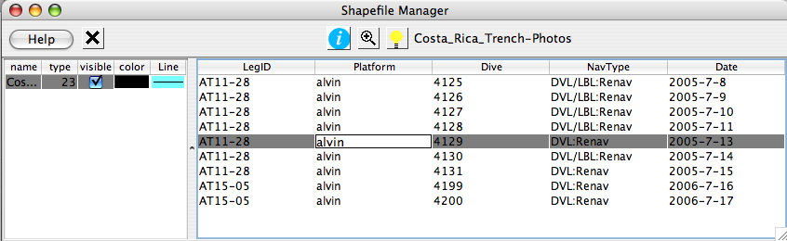
A website should open and show Find dive 4129 and Click on the link. Now you should see a window like this.
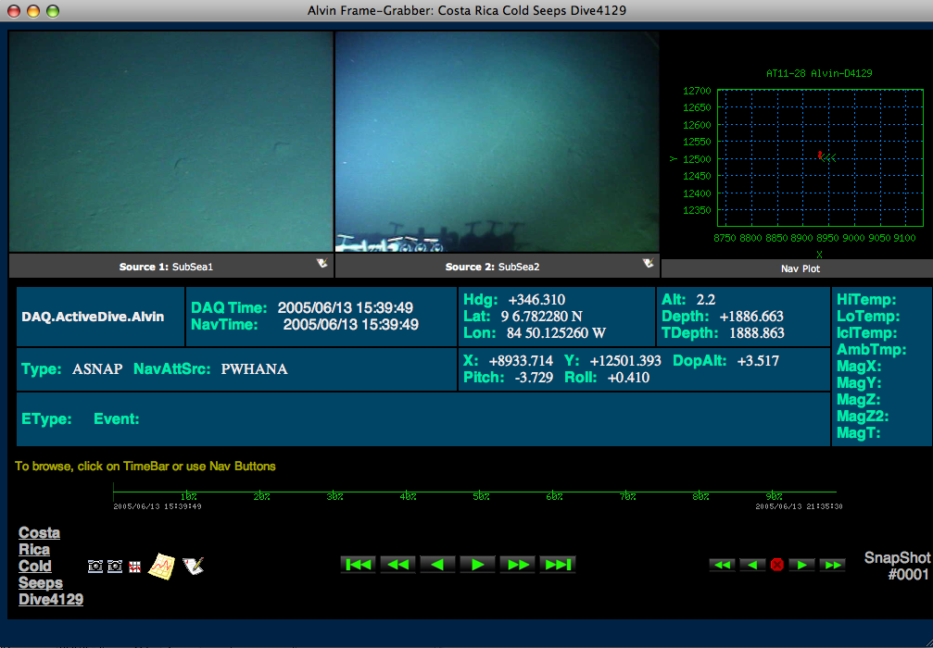

Click the photo button to see photos from this deep sea dive
Click on this button to see profile information.
- Now click on some of the photos and check out the different creatures. These are clams and tubeworms that are found in hyrothermal environments! Now, look at the profile information.
What was the deepest depth of this dive? (don’t forget units!!) _________________

How long did the Alvin stay below 1500meters? ____________________________
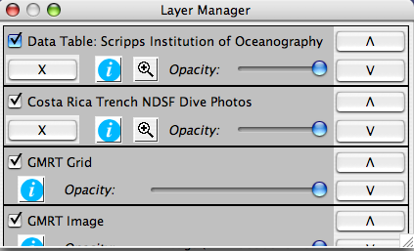
11) Go back to the main GeoMapApp window and zoom out to the full globe. Try importing at least 2 other types of data from the datasets menu. Use the zoom button on the Layer Manager to find the extent of the datasets. List here what data you looked at.

